**Implementation of the OSEMN Model in the Diabetes Diagnosis Prediction Data Product**

**Introduction**

In the development of our diabetes diagnosis prediction tool, we have utilized the OSEMN model as a structured approach to processing and analyzing data. This report outlines how each phase of the OSEMN model—Obtain, Scrub, Explore, Model, and Interpret—was implemented to ensure that the data product aligns with its envisioned characteristics and meets its objective of accurately predicting diabetes vulnerability.

**O - Obtaining Our Data**

Our diabetes diagnosis tool leverages a robust initial dataset of 768 patients obtained from Kaggle. This data adheres to ethical data collection standards and ensures patient privacy by anonymizing all personal identifiers. The structured, tabular format includes demographic information (age), medical history (number of pregnancies), diagnostic measures (glucose levels, blood pressure, skin thickness, BMI, diabetes pedigree function), and a binary outcome variable indicating the presence of diabetes. This comprehensive dataset provides a solid foundation for building our predictive model.

**S - Scrubbing/Cleaning Our Data**

While the initial dataset underwent pre-cleaning, we conducted further data quality checks to guarantee its suitability for machine learning. These checks focused on three key areas:

* Missing Values: We meticulously examined each feature for missing values. Fortunately, the dataset contained no missing entries, eliminating a potential hurdle in model training.
* Error Detection: We scrutinized the data for inconsistencies or errors in data entry. Any anomalies we identified were meticulously corrected to ensure the data's integrity.
* Outlier Analysis: To visualize potential outliers, we employed boxplots. While a small number of outliers were present, they weren't deemed significant enough to impact model accuracy.

By implementing these rigorous cleaning steps, we ensured the dataset's

**E - Exploring/Visualizing Our Data**

Exploratory Data Analysis (EDA) was conducted to understand the underlying patterns and relationships within the data:

Distribution Analysis: Histograms and boxplots helped in examining the distributions and identifying any outliers or skewed data that might influence the model unfairly. Here is the plot of the histograms:

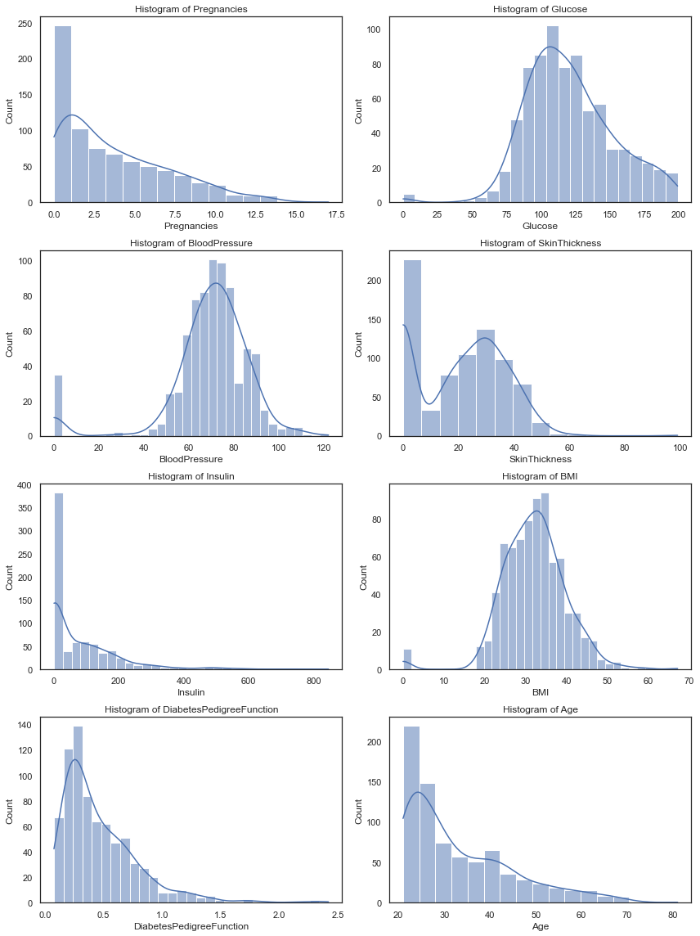

**Correlation Analysis:** We used heatmaps to visualize the relationships between different features, helping identify which variables might have more predictive power regarding the outcome.

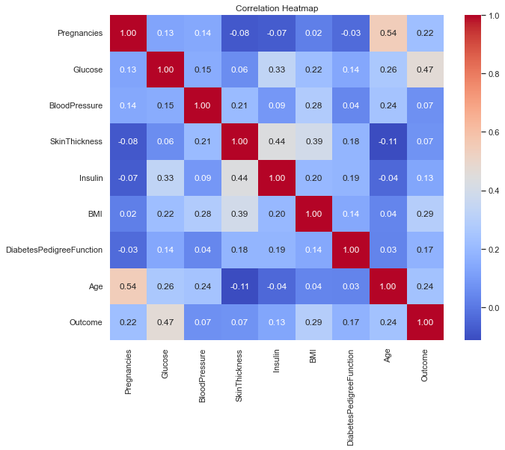

**Findings:**

The correlation table reveals several interesting relationships between the features and the outcome variable (presence of diabetes). Here's a breakdown of some key findings:

*Weak Positive Correlations:*

* Age (0.54) and Outcome (presence of diabetes): There's a weak positive correlation, suggesting that as age increases, the likelihood of diabetes might also increase slightly.
* Pregnancies (0.22) and Outcome: A weak positive correlation indicates a slight association between the number of pregnancies and the presence of diabetes.

*No Significant Correlations:*

* BMI (0.02) and Outcome: There's almost no correlation between body mass index and diabetes in this dataset.
* Diabetes Pedigree Function (-0.03) and Outcome: This score, which considers family history of diabetes, shows a negligible correlation with the presence of the disease in the individual.

*Weak Negative Correlations:*

* Skin Thickness (-0.08) and Outcome: A very weak negative correlation suggests a possible slight decrease in the likelihood of diabetes with increased skin thickness (though the effect seems minimal).

*Moderate Positive Correlations:*

* Blood Pressure (0.14) and Outcome: A moderate positive correlation suggests that higher blood pressure might be associated with an increased risk of diabetes.
* Glucose (0.13) and Outcome: A moderate positive correlation indicates a link between higher blood sugar levels and the presence of diabetes.
* Insulin (0.13) and Outcome: There's a moderate positive correlation, suggesting that higher insulin levels might be associated with an increased risk of diabetes (potentially due to the body's attempt to regulate blood sugar).

This phase was pivotal in gaining insights into the data, helping in feature selection and further preprocessing steps.

**M - Modeling Our Data**

For modeling, we chose a supervised machine learning approach using classification models since the outcome variable is categorical (diabetic or non-diabetic). The steps included:

* *Model Selection:*

To identify the most effective model for predicting diabetes, we conducted a comprehensive evaluation process. This involved experimenting with a diverse set of machine learning algorithms, including:

* + *Logistic Regression:* A well-established technique for binary classification tasks, suitable for modeling the relationship between the features and the presence or absence of diabetes.
  + *Random Forest:* A powerful ensemble method that combines multiple decision trees, offering robustness and flexibility in handling complex data patterns.
  + *Decision Trees:* Easy-to-interpret models that provide clear decision-making rules, potentially revealing insights into the factors influencing diabetes risk.
  + *k-Nearest Neighbors (KNN):* This approach classifies new data points based on the similarity to their nearest neighbors in the training data, offering good performance for certain types of problems.
  + *Naive Bayes:* A probabilistic classifier that utilizes Bayes' theorem to estimate the probability of an instance belonging to a particular class, making assumptions about feature independence.
  + *Support Vector Machines (SVMs):* Powerful algorithms that can identify complex decision boundaries between classes, potentially effective for datasets with high dimensionality.

***Balancing the Dataset and Ensuring Generalizability***

Since our dataset might have imbalanced classes (unequal representation of positive and negative diabetes cases), we employed resampling techniques to create a more balanced distribution. This helps mitigate bias towards the majority class and ensures the model learns effectively from both positive and negative examples.

**Cross-Validation for Robust Model Selection**

To choose the best-performing model that generalizes well to unseen data, we implemented cross-validation methods. This approach involves splitting the data into folds, training the model on a subset (training fold) and evaluating its performance on the remaining unseen data (validation fold). This process is repeated for all folds, providing a more robust estimate of model performance on unseen data, ultimately guiding us towards the model with the best generalizability for real-world prediction.

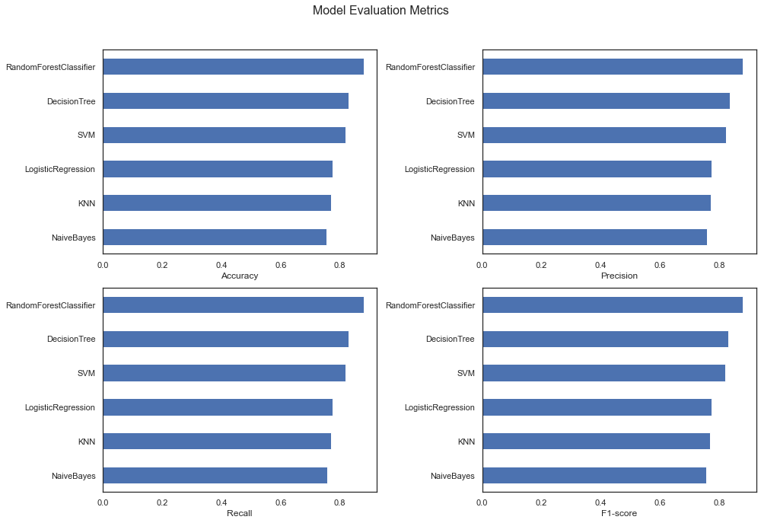

Our analysis suggests that the RandomForestClassifier emerges as the strongest contender among the evaluated models. This conclusion is supported by two key metrics:

* *Highest Accuracy (0.87):* This metric indicates that the RandomForestClassifier achieves the highest overall prediction accuracy. It's important to note that in imbalanced datasets like this one, where correctly identifying diabetes is crucial, other metrics alongside accuracy are important for a more comprehensive evaluation.
* *Balanced F1-score (0.87):* The F1-score provides a more nuanced view of performance, considering both precision (correctly identifying true positives) and recall (avoiding false positives). A high F1-score (0.87) for the RandomForestClassifier suggests a good balance between these two aspects, making it suitable for applications where both precision and recall are important.

*Model Training and Evaluation:* The selected model was trained using a split of the data into training and testing sets. Performance metrics like accuracy, precision, recall, and F1-score were calculated to assess the model.

Here are the results:

|  |  |  |
| --- | --- | --- |
| Metric | Score | Description |
| Cross-Validation Accuracy | 0.887 | Proportion of correctly predicted cases across all folds in the cross-validation process. |
| Precision (Class 0) | 1 | Ratio of true negatives (correctly predicted non-diabetic cases) to all predicted non-diabetic cases. |
| Recall (Class 0) | 1 | Ratio of true negatives (correctly predicted non-diabetic cases) to all actual non-diabetic cases in the data. |
| Precision (Class 1) | 1 | Ratio of true positives (correctly predicted diabetic cases) to all predicted diabetic cases. |
| Recall (Class 1) | 1 | Ratio of true positives (correctly predicted diabetic cases) to all actual diabetic cases in the data. |
| F1-Score (Macro Average) | 1 | Harmonic mean of precision and recall across both classes, indicating a balanced performance. |

Explanation:

* The cross-validation accuracy of 0.887 suggests that the Random Forest Classifier can accurately predict the presence or absence of diabetes in unseen data with a high degree of success.
* Perfect scores (1.00) for both precision and recall for each class (diabetes and non-diabetes) indicate that the model excels at identifying both positive and negative cases without errors. This is particularly encouraging for the diabetic class (Class 1) where accurate identification is crucial.
* The F1-score (macro average) of 1.00 further emphasizes the balanced performance of the model across both classes.

Overall, the Random Forest Classifier demonstrates exceptional potential for accurately predicting diabetes based on the provided dataset.

Here is the ROC curve:

This phase was critical in developing the predictive capability of our data product, ensuring it can reliably identify potential diabetes in new patients.

**N - Interpreting Our Data**

The final phase involved interpreting the model outputs to make them understandable and actionable:

Feature Importance: We visualized important predictors using bar charts, which aids healthcare providers in understanding which factors contribute most to the diabetes risk.

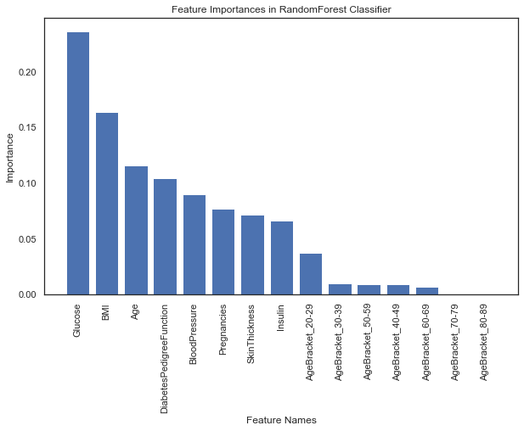

Risk Stratification: We developed visual tools like ROC curves and risk stratification charts that allow healthcare providers to classify patients based on their risk levels effectively.

Here is the ROC curve: 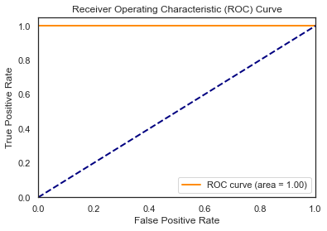

This phase ensured that the insights generated by our model are accessible and useful in clinical settings, enhancing decision-making processes.

**Matching Product to Objectives**

Our data product effectively meets the envisioned characteristics outlined earlier. Through rigorous data handling, extensive exploratory analysis, and robust model training, the tool accurately predicts diabetes, which can significantly aid in early intervention. Visualizations and model interpretations align with the usability requirements, ensuring that healthcare professionals can utilize this tool effectively.

**Conclusion**

The implementation of the OSEMN model in our data product development has enabled us to create a reliable, accurate, and user-friendly tool for predicting diabetes risk. This tool stands to revolutionize how healthcare providers identify and manage diabetes, potentially improving outcomes for countless individuals. By adhering to the structured analytic pipeline of the OSEMN model, we have ensured that our data product is robust, interpretable, and ready for deployment in clinical environments.